# 

SUBMITTED BY –

Debangshu Das

Surajit Samanta

Sandip Patra

Swarnadip Sutradhar

Asis Maji

Gobinda Giri.

UNDER THE GUIDANCE OF-

SMT. SAHELI DASH

SESSION: 2022-2023

DATE:

PLACE: CONTAI

DIPLOMA IN COMPUTER SCIENCE AND TECHNOLOGY

CONTAI POLYTECHNIC

**MINOR PROJECT ON**

**INTERACTIVE WEBSITE DEVELOPMENT OF AN INSTITUTE**

**ACKNOWLEDGEMENTS**

We are overwhelmed in all humbleness and gratefulness to acknowledge my depth to all those who have helped me to put these ideas, well above the level of simplicity and into something concrete.

We would like to express my special thanks of gratitude to OUR teacher "Mrs. Saheli Dash" who gave me the golden opportunity to do this wonderful project on the topic INTERACTIVE WEBSITE DEVELOPMENT OF AN INSTITUTE, which also helped us doing a lot of research and we have learnt about so many new things. We are really thankful to them.

Any attempt at any level can 't be satisfactorily completed without the support and guidance of my Team Members.

We would like to thank our entire team who helped me a lot in gathering different information collecting data and guiding me from time to time in making this project, despite of their busy schedules, they gave me different ideas in making this project unique.

Date :

Place: CONTAI

…………………………………

Signature of

Project Guidance

…………………………………

Signature Of

External Examiner

Certified that this project report titled “INTERACTIVE WEBSITE DEVELOPMENT OF AN INSTITUTE” is the bonafide work of “Debangshu Das”, “Surajit Samanta”, “Sandip Patra”, “Swarnadip Sutradhar”, “Asis Maji”, “Gobinda Giri” who carried out the project work under my supervision.

BONAFIDE CERTIFICATE

TABLE OF CONTENTS

INTRODUCTION………………………………………………………………… 1

Purpose of the project……………………………………………….. 1

Current and Proposed System……………………………………… 1

Glossary…………………………………………………………………. 2

Advantages……………………………………………………………. 2

REQUIREMENTS…………………………………………………………….…… 3

Software Requirements………………………………………….…… 3

Hardware Requirements……………………………………………. 3

Functional Requirements……………………………………….……. 3

SYSTEM DESIGN………………………………………………………………… 4

WEB PAGE DESIGN……………………………………………………. 5

SOURCE CODE………………………………………………….……………... 6

Header Section………………………………………….…………….. 9

Slider Section………………………………………………………….. 10

Department Section………………………………………………. 11

About Section………………………………………………………… 13

Mission & Vision Section……………………………………………. 14

Join Telegram Section……………………………………..………. 15

Administration Section……………………………………………… 16

Principal’s Desk Section …………………………………………….. 17

Find Us On Google Map Section………………………………….. 18

Footer Section…………………………………………….………….. 19

Copyright Section…………………………………………………… 20

TESTING………………………………………………………………………… 22

FUTURE SCOPE OF THE PROJECT………………………………………….. 27

REFERENCE……………………………………………………………………. 28

END OF THE PROJECT………………………………………………..……… 29

1 |page

The growing significance of websites for various organizations is well known. In recognizing that we decided to develop a website for the institute which compromises of all the required information about the institute.

* **Purpose of the project**:

The purpose of our project is to design, publish and maintain a website for our college which consists of all the information regarding the college like infra structure, faculty, transport facilities, etc.,

* **Current and Proposed System**:
* Current System:

As the existing website is not maintained and the domain has been blocked there is a need for new one.

* Proposal System:

Initially the college authorities had the feeling of maintaining a comprehensive website for information exchange apart from existing one(static). We used all the possible ways to monitor the data and maintain and format the data requested by the authority. Also to formulated the text to embed into World Wide Web. The data is about to change all the time so we will update it all the time possible.

**INTRODUCTION**

2 |page

* **Glossary:**

|  |  |
| --- | --- |
| **TERM** | **DEFINITION** |
| HTML | Hyper Text Markup Language |
| JSS | JavaScript Certificate |
| CSS | Cascading Style Sheets |

The above technologies are required to implement the requirements due to following advantages.

* **Advantages :**
* Easy to navigate
* Provides all the comprehensive information about the college
* Flash items are provided where ever necessary
* All the nostalgic images are provided in Slider section

3 |page

REQUIREMENTS

* **Software Requirements:**
* OPERATING SYSTEM :WINDOWS 8.1,10,11
* BROWSER :INTERNET EXPLORER OR ANY HTTP BROWSER
* WEB SERVER : IIS
* CLIENT SIDE SCRIPTING : CSS, JAVA SCRIPT
* CONNECTION : TCP/IP
* PROTOCOL : HTTP,SMTP,POP3,WAP
* CODE EDDITOR : SUBLIME TEXT, NOTEPAD++, ETC
* **Hardware Requirements:**
* Processor: Intel Pentium IV or above
* Ram: 512 MB or more
* Hard Disk: 40 GB or more
* **Functional Requirements:**
* The system provides all the information about the college in detail
* The system gives in detail description of our college infrastructure
* All the information about the faculty and labs are provided in department wise
* All the necessary information is rendered with proper images and flash slides for better navigation
* Proper information regarding the mode of transport and available means is also included.

4 |page

**SYSTEM DESIGN :**

System design is the solution to the creation of a new system. This phase is composed of several systems. This phase focuses on the detailed implementation of the feasible system. It emphasis on translating design specifications to performance specification. System design has two phases of development logical and physical design. During logical design phase the analyst describes inputs (sources), out puts (destinations), all in a format that meats the uses requirements. The analyst also specifies the user needs and at a level that virtually determines the information flow into and out of the system and the data resources. Physical design produces the working system by defining the design

**WEB PAGE DESIGN :**

Web Forms are based on ASP.NET. Working with Web Forms is similar to working with Windows Forms. But the difference is that we will create Web pages with Web forms that will be accessible by a Web browser. Web Forms are Web pages that serve as the user interface for a Web application. A Web Forms page presents information to the user in any browser or client device and implements application logic using server-side code.

5 |page

**SOURCE CODE**

<!DOCTYPE html>

<html lang=**"en"**>

<head>

<meta charset=**"utf-8"**>

<meta http-equiv=**"x-ua-compatible"** content=**"ie=edge"**>

<meta name=**"viewport"** content=**"width=device-width, initial-scale=1.0"**>

<title>**Contai Polytechnic** *&#8211;* **Govt. Of West Bengal**</title>

<link rel=**"shortcut icon"** href=**"assets/images/icon.ico"**>

<link rel=**"stylesheet"** href=**"assets/css/vendor/bootstrap.min.css"**>

<link rel=**"stylesheet"** href=**"assets/css/vendor/slider.min.css"**>

<link rel=**"stylesheet"** href=**"assets/css/main.css"**>

<link rel=**"stylesheet"** href=**"assets/css/socialbtn.css"**>

<link rel=**"stylesheet"** href=**"assets/css/vendor/icons.min.css"**>

<link rel=**"stylesheet"** href=**"assets/css/vendor/flaticonis.css"**>

<link rel=**"stylesheet"** href=**"assets/css/vendor/flaticon.css"**>

<link rel=**"stylesheet"** href=**"assets/css/vendor/animation.min.css"**>

<link rel=**"stylesheet"** href=**"assets/css/vendor/gallery.min.css"**>

<link rel=**"stylesheet"** href=**"assets/css/vendor/cookie-notice.min.css"**>

<link rel=**"stylesheet"** href=**"assets/css/default.css"**>

<link rel=**"stylesheet"** href=**"assets/css/theme-orange.css"**>

<script src=**'https://www.google.com/recaptcha/api.js'**></script>

<script src=**"https://kit.fontawesome.com/e2186e067e.js"** crossorigin=**"anonymous"**></script>

<style>

**:root {**

**--header-bg-color: #040402;**

**--nav-item-color: #f5f5f5;**

**--hero-bg-color: #040402;**

**--section-1-bg-color: #111111;**

**--section-2-bg-color: #191919;**

**--section-3-bg-color: #111111;**

**--section-4-bg-color: #040402;**

**--section-5-bg-color: #111111;**

**--section-6-bg-color: #040402;**

**--section-7-bg-color: #191919;**

**--section-8-bg-color: #040402;**

**--footer-bg-color: #111111;**

**}**

**[class^="flaticon-"]:before,**

**[class*=" flaticon-"]:before,**

**[class^="flaticon-"]:after,**

**[class*=" flaticon-"]:after {**

**font-family: Flaticon;**

**font-style: normal;**

**}**

</style>

6 |page

<!-- Global site tag (gtag.js) - Google Analytics -->

<script async src=**"https://www.googletagmanager.com/gtag/js?id=G-CZB96WP2J0"**></script>

<script>

window.dataLayer **=** window.dataLayer **||** **[];**

***function*** gtag**()** **{**

dataLayer.push**(**arguments**);**

**}**

gtag**(**'js'**,** ***new*** Date**());**

gtag**(**'config'**,** 'G-CZB96WP2J0'**);**

</script>

<!-- Google Tag Manager -->

<script>

**(*function*(**w**,** d**,** s**,** l**,** i**)** **{**

w**[**l**]** **=** w**[**l**]** **||** **[];**

w**[**l**].**push**({**

'gtm.start'**:** ***new*** Date**().**getTime**(),**

event**:** 'gtm.js'

**});**

***var*** f **=** d.getElementsByTagName**(**s**)[**0**],**

j **=** d.createElement**(**s**),**

dl **=** l **!=** 'dataLayer' **?** '&l=' **+** l **:** ''**;**

j.async **=** ***true*;**

j.src **=**

'https://www.googletagmanager.com/gtm.js?id=' **+** i **+** dl**;**

f.parentNode.insertBefore**(**j**,** f**);**

**})(**window**,** document**,** 'script'**,** 'dataLayer'**,** 'GTM-NH68LSN'**);**

</script>

<!-- End Google Tag Manager -->

</head>

7 |page

<body>

<!-- Google Tag Manager (noscript) -->

<noscript><iframe src=**"https://www.googletagmanager.com/ns.html?id=GTM-NH68LSN"**

height=**"0"** width=**"0"** style=**"display:none;visibility:hidden"**></iframe></noscript>

<!-- End Google Tag Manager (noscript) -->

<div class=**"float-sm"**>

<div class=**"fl-fl float-fb"**>

<i class=**"fab fa-facebook-f"**></i>

<a href=**"https://www.facebook.com/groups/170775212937710"** target=**"_blank"**> **Like**</a>

</div>

<div class=**"fl-fl float-tw"**>

<i class=**"fab fa-twitter"**></i>

<a href=**"Follow"** target=**"_blank"**>**Follow**</a>

</div>

<div class=**"fl-fl float-gp"**>

<i class=**"fab fa-telegram"**></i>

<a href=**"https://t.me/joinchat/lGpzxKbUs1s5NTll"** target=**"_blank"**>**Join**</a>

</div>

</div>

8 |page

HEADER SECTION

<!-- HEADER -->

<header id=**"header"** class=**"odd"**>

<nav data-aos=**"zoom-out"** data-aos-delay=**"800"** class=**"navbar navbar-expand"**>

<div class=**"container header"**>

<a href=**"#"** class=**"logo"**><img src=**"assets/images/logo.png"** ></a>

<div class=**"ml-auto"**></div>

</br>

<ul class=**"navbar-nav items"**>

<li class=**"nav-item dropdown"**>

<a href=**"#"** class=**"nav-link"**>**Home**</a>

</li>

<li class=**"nav-item"**>

<a href=**"About Us"** class=**"nav-link"**>**About Us**</a>

</li>

<li class=**"nav-item"**>

<a href=**"Academics"** class=**"nav-link"**>**Academics**</a>

</li>

<li class=**"nav-item"**>

<a href=**"TPO"** class=**"nav-link"**>**TPO**</a>

</li>

<li class=**"nav-item"**>

<a href=**"https://www.contaipolytechnic.com/notice-tenders/"** class=**"nav-link"**>**Notice** & **Tenders**</a>

</li>

<li class=**"nav-item"**>

<a href=**"Students"** class=**"nav-link"**>**Students**</a>

</li>

</ul>

<ul class=**"navbar-nav toggle"**>

<li class=**"nav-item"**>

<a href=**"menu"** class=**"nav-link"** data-toggle=**"modal"** data-target=**"menu"**>

</a>

</li>

</ul>

<ul class=**"navbar-nav action"**>

<li class=**"nav-item ml-5"**>

<a href=**"https://www.contaipolytechnic.com/"** class=**"btn ml-lg-auto dark-button portal-btn"**><i class=**"icon-"**></i>**Mail Us**</a>

</li>

</ul>

<ul class=**"navbar-nav action"**>

<li class=**"nav-item ml-5"**>

<a href=**"https://www.contaipolytechnic.com/"** class=**"btn ml-lg-auto dark-button portal-btn"**><i class=**"icon-"**></i>**Contact Us**</a>

</li>

</ul>

</div>

</nav>

</header>

9 |page

SLIDER SECTION

<!-- SLIDER -->

<section id=**"slider"** class=**"hero p-0 odd"**>

<div class=**"swiper-container full-slider featured animation slider-h-100"**>

<div class=**"swiper-wrapper"**>

<!-- Item 1 -->

<div class=**"swiper-slide slide-center"**>

<img data-aos=**"zoom-out-up"** data-aos-delay=**"800"** src=**"assets/images/collage1.jpg"** style=**"width:2000px;height:1000px;"**class=**"library"** alt=library>

</div>

<div class=**"swiper-slide slide-center"**>

<img data-aos=**"zoom-out-up"** data-aos-delay=**"800"** src=**"assets/images/CONTAIPOLYTECHNIC-1.jpg"** style=**"width:2000px;height:1000px;"**class=**"library"** alt=library>

</div>

<div class=**"swiper-slide slide-center"**>

<img data-aos=**"zoom-out-up"** data-aos-delay=**"800"** src=**"assets/images/workshop.jpg"** style=**"width:2000px;height:1000px;"**class=**"library"** alt=library>

</div>

<div class=**"swiper-slide slide-center"**>

<img data-aos=**"zoom-out-up"** data-aos-delay=**"800"** src=**"assets/images/boyshostal.jpg"** style=**"width:2000px;height:1000px;"**class=**"library"** alt=library>

</div>

<div class=**"swiper-slide slide-center"**>

<img data-aos=**"zoom-out-up"** data-aos-delay=**"800"** src=**"assets/images/cstlab.jpg"** style=**"width:2000px;height:1000px;"**class=**"library"** alt=library>

</div>

<div class=**"swiper-slide slide-center"**>

<img data-aos=**"zoom-out-up"** data-aos-delay=**"800"** src=**"assets/images/smartclass.jpg"** style=**"width:2000px;height:1000px;"**class=**"library"** alt=library>

</div>

</div>

<div class=**"swiper-pagination"**></div>

</div>

</section>

10 |page

DEPARTMENTS SECTION

<!-- Departments Section -->

<section id=**"Departments List"** class=**"section-2 odd offers featured left"**>

<div class=**"container"**>

<div class=**"row intro"**>

<div class=**"col-12 col-md-9 align-self-center text-center text-md-left"**>

<h2 class=**"featured"**>**Departments List**</h2>

<p>**Click to select departments.**</p>

</div>

</div>

<div class=**"row justify-content-center text-center items"**>

<div class=**"col-12 col-md-6 col-lg-4 item"**>

<div class=**"card featured"**>

<h4> **Department of Science** & **Humanities**</h4>

<img src=**"assets/svg/humanities.jpg"** alt=**"humanities"** style=**"width:500px;height:150px;margin-left:auto;margin-right:auto;"**>

<p>**Basic Science : Mathematics, Physics, Chemistry** </br> **Humanities : Economics** & **Accountancy, Communicative English, Development of Life Skill**</p><a href=**"https://www.contaipolytechnic.com/academics/departments/department-of-science-humanities/"**>**Click Here For More Info** </a>

</div>

</div>

<div class=**"col-12 col-md-6 col-lg-4 item"**>

<div class=**"card"**>

<h4> **Department of Mechanical Engineering**</h4>

<img src=**"assets/svg/mechanical.jpg"** alt=**"mechanical"** style=**"width:500px;height:100px;margin-left:auto;margin-right:auto;"**>

<p>**Thermal Engineering, Fluid Mechanics, Automobile, Strength of Materials, Heat Transfer, Refrigeration** & **Air Conditioning.**</p><a href=**"https://www.contaipolytechnic.com/academics/departments/department-of-mechanical-engineering/"**>**Click Here For More Info** </a>

</div>

</div>

<div class=**"col-12 col-md-6 col-lg-4 item"**>

<div class=**"card"**>

<h4> **Department of Chemical Engineering**</h4>

<img src=**"assets/svg/chemical.jpg"** alt=**"chemical"** style=**"width:500px;height:150px;margin-left:auto;margin-right:auto;"**>

<p>**Momentum Transfer, Engineering Thermodynamics, Energy Engineering, Mass Transfer, Heat Transfer,** </p><a href=**"https://www.contaipolytechnic.com/academics/departments/department-of-chemical-engineering/"**>**Click Here For More Info** </a>

</div>

</div>

<div class=**"col-12 col-md-6 col-lg-4 item"**>

<div class=**"card"**>

<h4> **Department of Civil Engineering**</h4>

<img src=**"assets/svg/civil.jpg"** alt=**"civil"** style=**"width:500px;height:150px;margin-left:auto;margin-right:auto;"**>

<p>**Building Material Construction, Strength of Material, Hydraulics, Mechanics of Structures, Concrete Technology, Field Surveying, Geotechnical Engineering, Irrigation Engineering.**</p>

<a href=**"https://www.contaipolytechnic.com/academics/departments/department-of-civil-engineering/"**>**Click Here For More Info** </a>

</div>

</div>

11 |page

<div class=**"col-12 col-md-6 col-lg-4 item"**>

<div class=**"card"**>

<h4> **Department of Computer Science** & **Technology**</h4>

<img src=**"assets/svg/Computer-Science.jpg"** alt=**"Computer-Science"** style=**"width:500px;height:150px;margin-left:auto;margin-right:auto;"**>

<p>**Computer programming, PYTHON, JAVA Programming, DBMS, Operating System, Computer Networking.**</p>

<a href=**"https://www.contaipolytechnic.com/academics/departments/department-of-computer-science-technology/"**>**Click Here For More Info** </a>

</div>

</div>

<div class=**"col-12 col-md-6 col-lg-4 item"**>

<div class=**"card featured"**>

<h4> **Department of Electrical Engineering**</h4>

<img src=**"assets/svg/electrical.jpg"** alt=**"electrical"** style=**"width:500px;height:150px;margin-left:auto;margin-right:auto;"**>

<p>**Electrical Machine LabPower System, Industrial/ Power Electronics, Measurement Lab, Circuit Theory, Electrical Workshop, Utilization And Traction, Switch Gear**</p>

<a href=**"https://www.contaipolytechnic.com/academics/departments/department-of-electrical-engineering/#"**>**Click Here For More Info** </a>

</div>

</div>

<div class=**"col-12 col-md-6 col-lg-4 item"**>

<div class=**"card featured"**>

<h4> **Department of Electronics** & **Telecommunication Engineering**</h4>

<img src=**"assets/svg/electronics.jpg"** alt=**"electronics"** style=**"width:500px;height:150px;margin-left:auto;margin-right:auto;"**>

<p>**Consumer Electronics, Electronics instrumentation** & **Measurement, Linear Integrated Circuit, Circuit Theory, Basic Communication, Microwave Digital** & **Micro Communication System, Microcontroller 8051** & **It's Application.**</p>

<a href=**"https://www.contaipolytechnic.com/academics/departments/department-of-electronics-telecommunication-engineering/"**>**Click Here For More Info** </a>

</div>

</div>

<div class=**"col-12 col-md-6 col-lg-4 item"**>

<div class=**"card featured"**>

<h4> **Department of Pharmacy**</h4>

<img src=**"assets/svg/pharmacy.jpg"** alt=**"pharmacy"** style=**"width:500px;height:150px;margin-left:auto;margin-right:auto;"**>

<p>**Pharmaceutics, Pharmaceutical Chemistry, Pharmacognosy, Human Anatomy** & **Physiology, Pharmacology and Toxicology, Bio-Chemistry** & **Clinical Pathology, Community Pharmacy** & **Management, Pharmacotherapeutics**</p>

<a href=**"https://www.contaipolytechnic.com/academics/departments/department-of-pharmacy/"**>**Click Here For More Info** </a>

</div>

</div>

</div>

</div>

</section>

12 |page

ABOUT SECTION

<!-- About Section -->

<section id=**"about"** class=**"section-1 odd highlights image-right featured left"**>

<div class=**"container"**>

<div class=**"row"**>

<div class=**"col-12 col-md-6 align-self-center text-center text-md-left"**>

<div class=**"row intro"**>

<div class=**"col-12 p-0"**>

<h2 class=**"featured alt"**>**About Us**</h2>

<p><span class=**"dtext"**>**To spread technical education amongst the common people, to enable them to receive the benefits of State as well as Central Plans and also to improve the socio-economic structure of the local area, Contai Polytechnic was established in the undivided Medinipur District in the year 1990 with only one course namely Diploma in Civil Engineering and Rural Technology (DCERT). Later, Diploma in Civil Engineering has been introduced in place of DCERT with only 30 intake. Again in the year 1997, D.Pharm course was introduced with 30 intake. Moreover, from 2006 to 2010, five different courses have also been introduced. This has now become one of the largest Polytechnic in West Bengal.**

**It is worthwhile to mention that the main building was constructed in the year 1968.**

**At first, the office of the Contai Polytechnic was established at Contai S.D.O office in September 1991, with only few staffs and faculty members. Classes were conducted in the morning at Kshetromohan High School, Contai.**</span></p>

</div>

</div>

</div>

<div class=**"gallery col-12 col-md-6"**>

<a href=**"assets/images/collage.jpg"**>

<img src=**"assets/images/collage.jpg"** class=**"fit-image"** alt=**"Fit Image"**>

</a>

</div>

</div>

</div>

</section>

13 |page

MISSION & VISSION SECTION

<!-- Mission & Vission -->

<section id=**"vision"** class=**"section-2 odd highlights image-right featured left"**>

<div class=**"container"**>

<div class=**"row"**>

<div class=**"col-12 col-md-6 align-self-center text-center text-md-left"**>

<div class=**"row intro"**>

<div class=**"col-12 p-0"**>

<h2 class=**"featured alt"**>**MISSION** & **VISION**</h2>

<span class=**"dtext"**></span>

<h4 class=**"featured alt"**><blockquote>**Institute Mission Statements**</blockquote></h4>

<p><span class=**"dtext"**>**To introduce excellence in learning and teaching systems in technical education.**</span></br><span class=**"dtext"**>**To develop the quality of skilled engineers in the course of a planned program and professional skills training.**</span></br><span class=**"dtext"**>**To inspire students to learn and facilitate their overall development of the country and outclass in different disciplines of knowledge.**</span></p>

<h4 class=**"featured alt"**><blockquote>**Vision of Our Institute**</blockquote></h4>

<p><span class=**"dtext"**>**Contai Polytechnic envisages being a foremost Institute in pursuit of excellence in technical education and skill development and vocational education to serve the society.**</span>

</p>

</div>

</div>

</div>

<div class=**"gallery col-12 col-md-6"**>

<a href=**"assets/images/vision.png"**>

<img src=**"assets/images/vision.png"** class=**"fit-image"** alt=**"Vision"**>

</a>

</div>

</div>

</div>

</section>

14 |page

JOIN TELEGRAM SECTION

<!-- Join Contai Polytechnic Alumni Group -->

<section id=**"Join telegram"** class=**"section-5 odd highlights image-center featured"**>

<div class=**"container short"**>

<div class=**"row text-center intro"**>

<div class=**"col-12"**>

<h2>**Join Contai Polytechnic Alumni Group**</h2>

<p><span class=**"dtext"**>**As per directive of Higher Authority,a telegram group namely ' Contai Polytechnic Alumni' has been created. The main purpose of this group is to create a database of all the alumni of Contai Polytechnic and to keep a liaison with them.**

**So, all the staff of Contai Polytechnic are requested to join this group by clicking the below mentioned telegram link and also forward the link to the pass out students of this Institute so that this Institute can create a strong database of its alumni.**</span></p>

</br>

<div class=**"col-15 col-md-15 item"**>

<div class=**"card featured"**>

<a href=**"https://t.me/joinchat/lGpzxKbUs1s5NTll"**><h3>**Join**</h3></a>

</div>

</div>

</div>

</div>

</div>

</section>

15 |page

ADMINISTRATION SECTION

<!-- Administration -->

<section id=**"Administration"** class=**"section-6 odd logos offers featured"**>

<div class=**"overflow-holder"**>

<div class=**"container"**>

<div class=**"row text-center intro"**>

<div class=**"col-12"**>

<h2>**Administration**</h2>

<p class=**"text-max-800"**><!-- --></p>

</div>

</div>

<a href=**"https://www.contaipolytechnic.com/administration/meet-our-principal/"**><span class=**"badge tag"**>**Meet Our Principal**</span></a>

<a href=**"https://www.contaipolytechnic.com/administration/secretary-academic-council/"**><span class=**"badge tag"**>**Secretary, Academic Council**</span></a>

<a href=**"https://www.contaipolytechnic.com/governing-body/"**><span class=**"badge tag"**>**Governing Body**</span></a>

<a href=**"https://www.contaipolytechnic.com/anti-ragging-committee/"**><span class=**"badge tag"**> **Anti Ragging Cell/Committee**</span></a>

<a href=**"https://www.contaipolytechnic.com/administration/exam-cell/"**><span class=**"badge tag"**>**Exam-Cell**</span></a>

<a href=**"https://www.contaipolytechnic.com/students/placement/"**><span class=**"badge tag"**>**Training** & **Placement Cell**</span></a>

<a href=**"https://www.contaipolytechnic.com/administration/vocation-cell/"**><span class=**"badge tag"**>**Vocational Nodal Cell**</span></a>

</div>

</div>

</div>

</div>

</section>

16 |page

PRINCIPAL’S DESK SECTION

<!-- Principal's Desk -->

<section id=**"Principal's Desk"** class=**"section-7 carousel featured left"**>

<div class=**"overflow-holder"**>

<div class=**"container"**>

<div class=**"row text-center intro"**>

<div class=**"col-12"**>

<h2 style=**"color:#fff"**>**Principal's Desk**</h2>

<p class=**"text-max-800"**>**Contai Polytechnic, the 19th November, 2018**

**Today, on this gala day in which new students of Contai Polytechnic are being welcomed officially, Contai Polytechnic is launching its official website –**<a href=**"https://www.contaipolytechnic.com/"**>**www.contaipolytechnic.com**</a> **At the very beginning of this day, being the Head of the Institution, I convey my sincere gratitude all staff and students of Contai Polytechnic.**

**In the past 10 years, Contai Polytechnic has grown not only in strength and size but also in levels of excellence.**<a href=**"https://www.contaipolytechnic.com/administration/meet-our-principal/"**>**...Read More** </a></p>

</div>

</div>

<div class=**"row justify-content-center text-center items"**>

<div class=**"col-12 col-md-6 col-lg-4 item"**>

<div class=**"card featured"**>

<h2>**Dr. Prabir Maity**</h2>

<img src=**"assets/images/pic.jpg"** alt=**"humanities"** style=**"width:500px;height:250px;margin-left:auto;margin-right:auto;"**>

<h4>**Principal-In-Charge**</br>**Contai Polytechnic**</h4>

<a href=**"https://www.contaipolytechnic.com/administration/meet-our-principal/"**>**Click Here To Meet Our Principal** </a>

</div>

</div>

</div>

</div>

</section>

17 |page

FIND US ON GOOGLE MAP SECTION

<!-- Find us on Google Map -->

<section id=**"Find us on Google Map"** class=**"section-8 odd carousel featured"**>

<div data-vc-full-width=**"true"** data-vc-full-width-init=**"false"** class=**"vc_row wpb_row vc_row-fluid vc_custom_1644162463613"**>

<div class=**"wpb_column vc_column_container vc_col-sm-12"**>

<div class=**"vc_column-inner"**>

<div class=**"wpb_wrapper"**>

<div class=**"row"**>

<div class=**"col-md-12"**>

<div class=**"alterna-space "**></div>

</div>

</div>

<div class=**"alterna-title"**>

<h3 class=**"center bold"**>**Find us on Google Map**</h3>

<div class=**"line"**><span class=**"left-line"**></span><span class=**"right-line"**></span></div>

</div>

<div class=**"clear"**></div>

<div class=**"wpb_text_column wpb_content_element "**>

<div class=**"wpb_wrapper"**>

<p><iframe loading=**"lazy"** style=**"border: 0;"** src=**"https://www.google.com/maps/embed?pb=!1m18!1m12!1m3!1d3704.9077933160834!2d87.78714921541!3d21.783829366947163!2m3!1f0!2f0!3f0!3m2!1i1024!2i768!4f13.1!3m3!1m2!1s0x3a032124c3b7f323%3A0x36734f672b5a98d5!2sContai%20Polytechnic!5e0!3m2!1sen!2sin!4v1631197535896!5m2!1sen!2sin"**

width=**"100%"** height=**"450"** allowfullscreen=**"allowfullscreen"**></iframe></p>

</div>

</div>

</div>

</div>

</div>

</div>

<div class=**"vc_row-full-width"**></div>

</section>

18 |page

FOOTER SECTION

<!-- footer -->

<footer>

<section id=**"footer"** class=**"odd footer"**>

<div class=**"container"**>

<div class=**"row items"**>

<div class=**"col-10 col-lg-10 p-0"**>

<div class=**"row"**>

<div class=**"col-12 p-3 text-center text-lg-left item"**>

<div class=**"brand"**>

<a href=**"#"** class=**"logo"**><img src=**"assets/images/conpoly.jpg"** style=**"width:1000px;height:100px;"**></a>

</div></br>

<h4 class=**"title"**>**Get in Touch**</h4>

<ul class=**"navbar-nav"**>

<li class=**"nav-item"**>

<a href=**"#"** class=**"nav-link"**>

**Contact Us- (30220)-255462**</a>

</li>

<li class=**"nav-item"**>

<a href=**"#"** class=**"nav-link"**>

**Mail Us- polytechnic_contai@rediffmail.com** </a>

</li>

<li class=**"nav-item"**>

<a href=**"#"** class=**"nav-link"**>

**Address: Darua, Contai, Purba Medinipur, W.B.-721401**</a>

</li>

</ul>

<p>**Monday to Friday (From 10:30A.M. - 4.50 P.M.), Saturday (From 10:30A.M. - 1.50 P.M.)**

</p>

</div>

</div>

</div>

<div class=**"col-6 col-lg-4 p-2 text-center text-lg-left item"**>

<h4 class=**"title"**>**Important Links**</h4>

<ul class=**"navbar-nav"**>

<li class=**"nav-item"**>

<a href=**"https://webscte.co.in/"** class=**"nav-link"**>**W.B.S.C.T.E.**</a>

</li>

<li class=**"nav-item"**>

<a href=**"https://www.aicte-india.org/"** class=**"nav-link"**>**A.I.C.T.E.**</a>

</li>

<li class=**"nav-item"**>

<a href=**"https://www.education.gov.in/en"** class=**"nav-link"**>**M.H.R.D**</a>

</li>

</ul>

</div>

</div>

</div>

</div>

</section>

19 |page

COPYRIGHT SECTION

<section id=**"copyright"** class=**"p-3 odd copyright"**>

<div class=**"container"**>

<div class=**"row"**>

<div class=**"col-12 col-md-6 p-3 text-center text-lg-left"**>

<p><a href=**"#"**>**Privacy Policy**</a>

</div>

<div class=**"col-12 col-md-6 p-3 text-center text-lg-right"**>

<p><a href=**"#"**>**Terms** & **Conditions**</a></p>

</div>

</div>

</div>

</section>

<section id=**"Developer"** class=**"p-3 odd copyright"**>

<div class=**"container"**>

<div class=**"row"**>

<div class=**"col-12 col-md-6 p-3 text-center text-lg-left"**>

<p>**Developed by Debangshu Das, Surajit Samanta, Sandip Patra, Swarnadip Sutradhar, Asis Maji, Gobinda Giri.**</p>

</div>

<div class=**"col-12 col-md-6 p-3 text-center text-lg-right"**>

<p>**© 2022 Contai Polytechnic.**<a href=**"https://www.contaipolytechnic.com/"** target=**"_blank"**><span style=**"background: linear-gradient(90deg,#ff8a00,#e52e71);**

**-webkit-background-clip: text;**

**-webkit-text-fill-color: transparent;**

**-webkit-box-decoration-break: clone;**

**box-decoration-break: clone;**

**-webkit-text-decoration-color: #ff8a00!important;**

**text-decoration-color: #ff8a00!important;"**>**All right reserved**</span></a>**.**</p>

</div>

</div>

</div>

</section>

</footer>

20 |page

<div id=**"scroll-to-top"** class=**"odd scroll-to-top"**>

<a href=**"#header"** class=**"smooth-anchor"**>

<i class=**""**><p>**top**</p></i>

</a>

</div>

<!--Start of Tawk.to Script -->

<script type=**"text/javascript"**>

***var*** Tawk_API **=** Tawk_API **||** **{},**

Tawk_LoadStart **=** ***new*** Date**();**

**(*function*()** **{**

***var*** s1 **=** document.createElement**(**"script"**),**

s0 **=** document.getElementsByTagName**(**"script"**)[**0**];**

s1.async **=** ***true*;**

s1.src **=** 'https://embed.tawk.to/5f5371724704467e89ec6588/default'**;**

s1.charset **=** 'UTF-8'**;**

s1.setAttribute**(**'crossorigin'**,** '*'**);**

s0.parentNode.insertBefore**(**s1**,** s0**);**

**})();**

</script>

<!--End of Tawk.to Script-->

<script src=**"assets/js/vendor/jquery.min.js"**></script>

<script src=**"assets/js/vendor/jquery.easing.min.js"**></script>

<script src=**"assets/js/vendor/jquery.inview.min.js"**></script>

<script src=**"assets/js/vendor/popper.min.js"**></script>

<script src=**"assets/js/vendor/bootstrap.min.js"**></script>

<script src=**"assets/js/vendor/ponyfill.min.js"**></script>

<script src=**"assets/js/vendor/slider.min.js"**></script>

<script src=**"assets/js/vendor/animation.min.js"**></script>

<script src=**"assets/js/vendor/progress-radial.min.js"**></script>

<script src=**"assets/js/vendor/bricklayer.min.js"**></script>

<script src=**"assets/js/vendor/gallery.min.js"**></script>

<script src=**"assets/js/vendor/shuffle.min.js"**></script>

<script src=**"assets/js/vendor/cookie-notice.min.js"**></script>

<script src=**"assets/js/main.js"**></script>

</body>

</html>

21 |page

TESTING

OUTPUT:

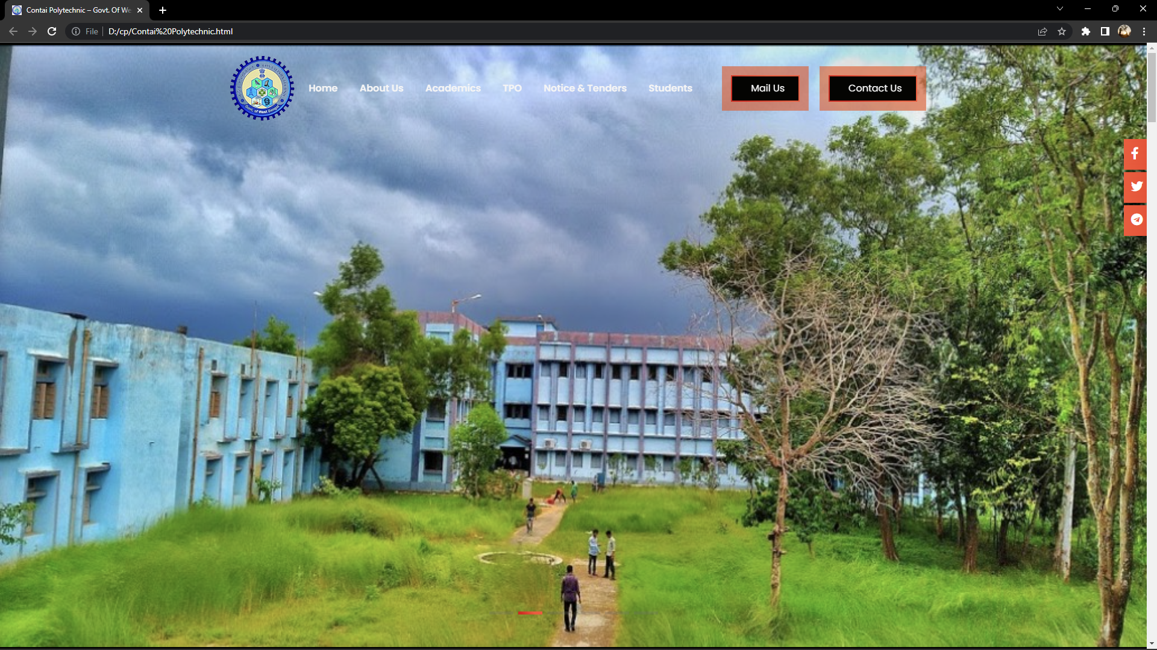

22 |page

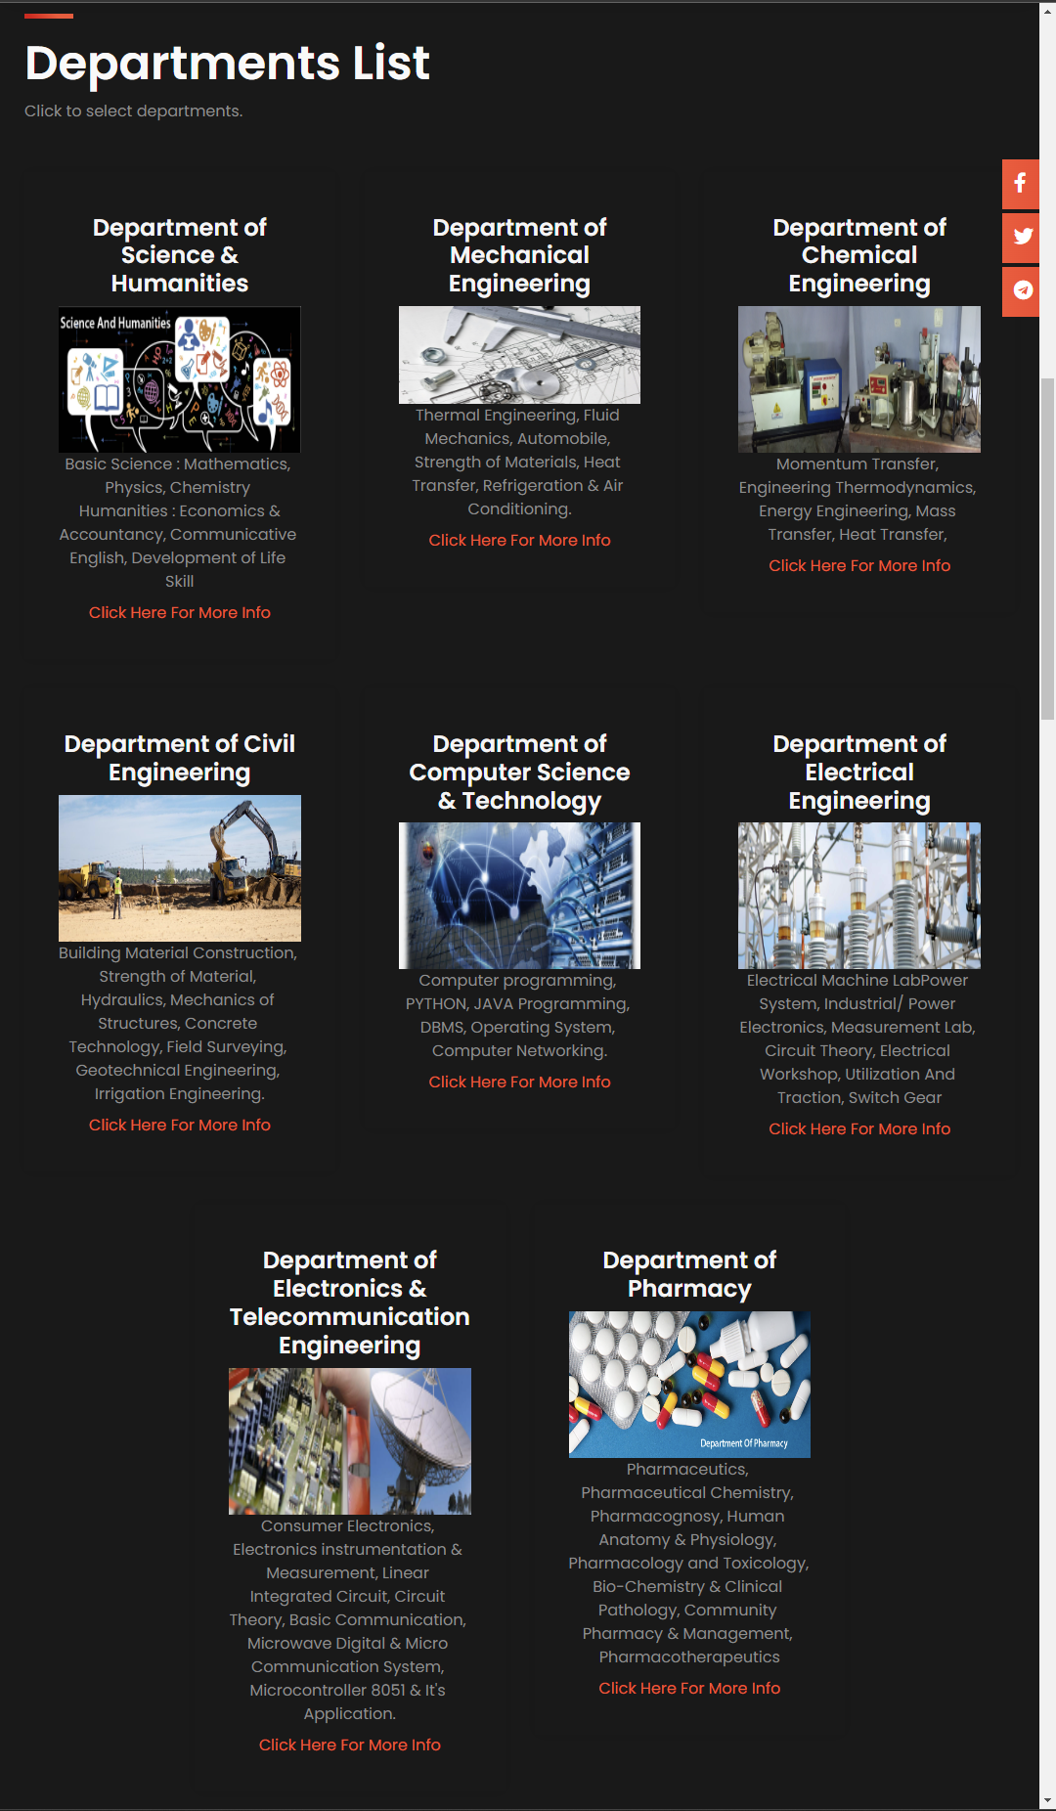

23 |page

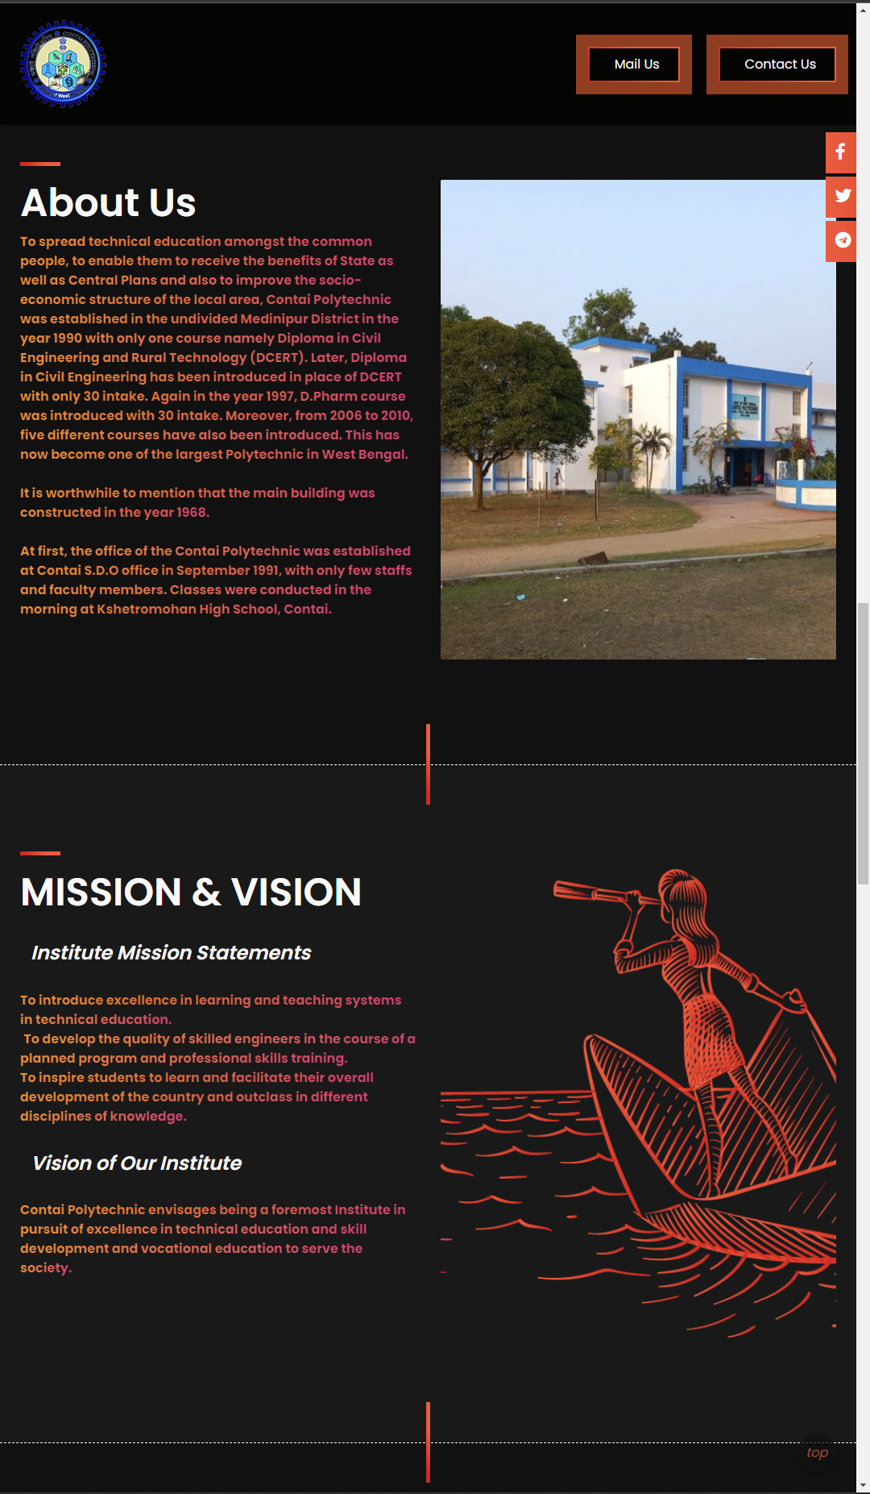

24 |page

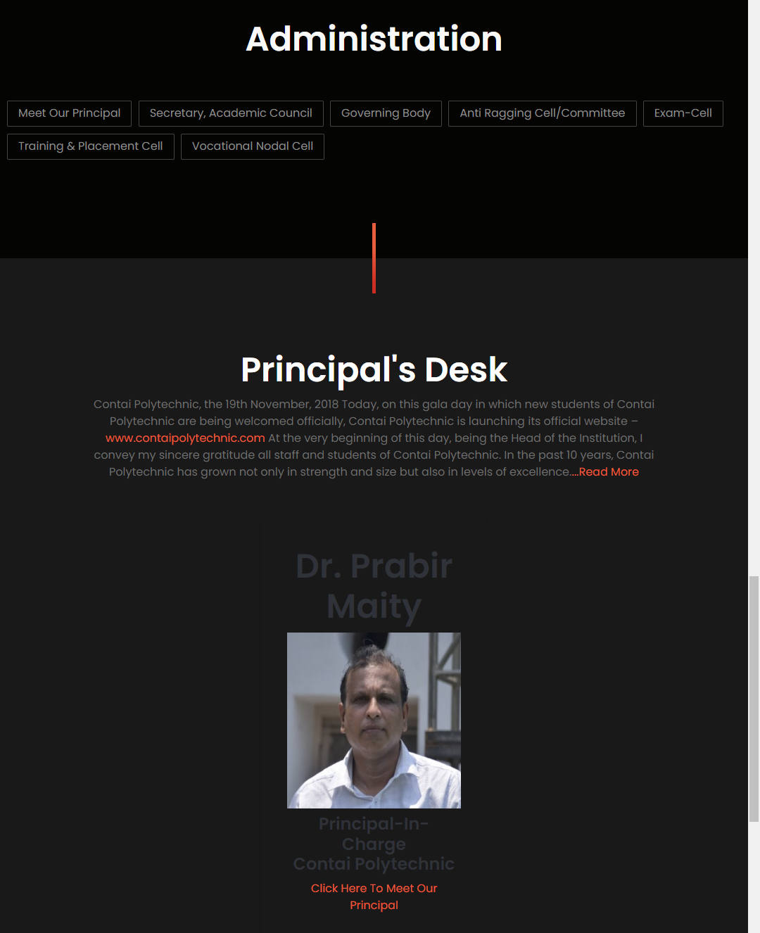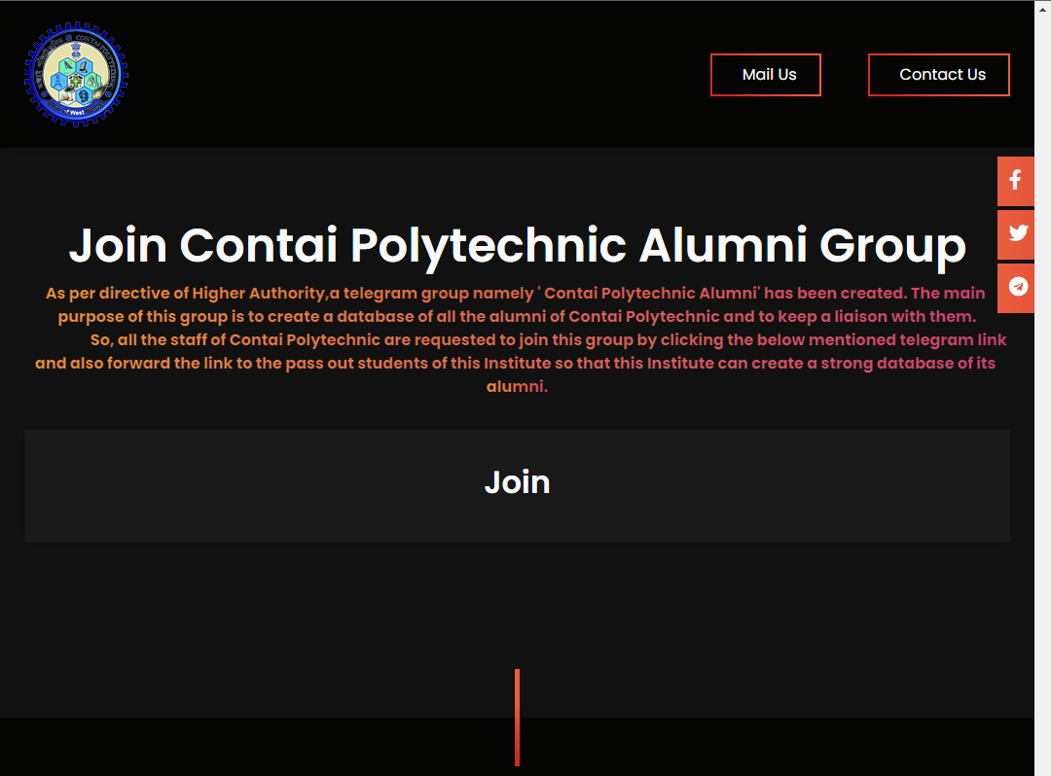

25 |page

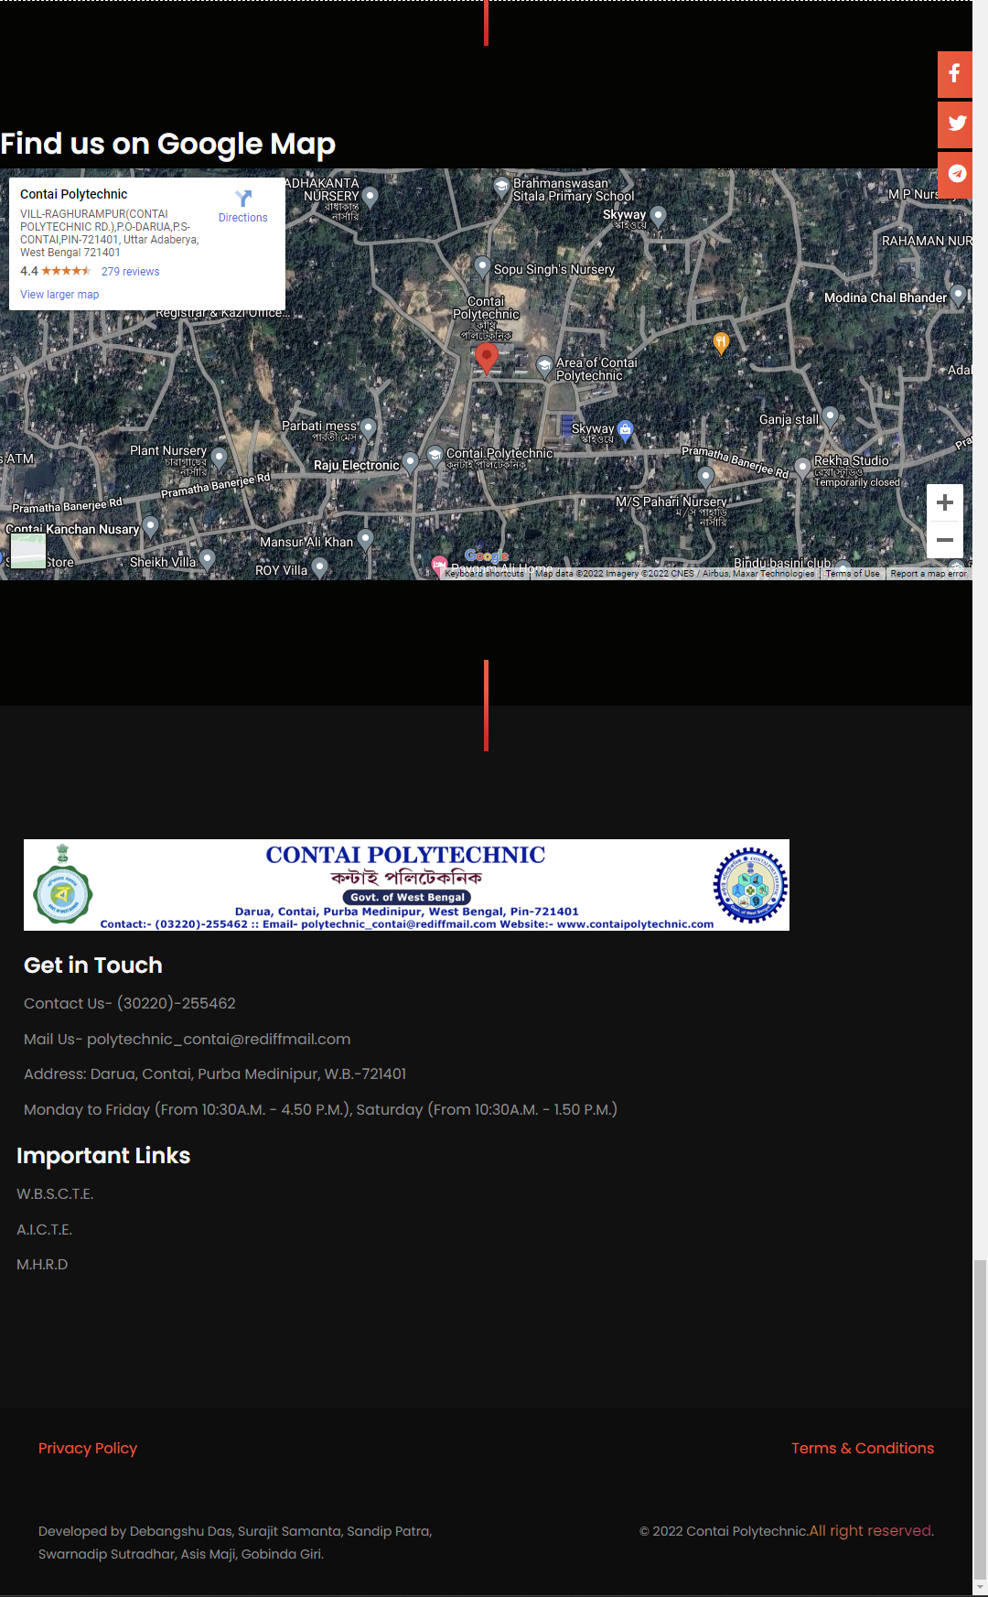

26 |page

FUTURE SCOPE OF THE PROJECT

1. Domain: Domain is web address that is linked to the website’s server.
2. Local Server: A local server is small server at the department’s home network. Which will be only accessible if anyone is in faculty premises and connected to the library Wi-Fi.
3. Hosting: The website need to be placed in a server that is connected to internet. Usually large organization have their own server division. As Accounting & information system doesn’t have any experts it should be hosted by 3rd party.
4. ERP: To securely conduct user related registration, payment, authorizations etc. organizations often use Enterprise Resource planning (ERP)software’s. ERP ensures security and reliability. It also helps reduces hacking related problems.
5. Server Management: If we use only local server the overall cost will reduce but then will need an expert to manage the server.
6. Forum: A separate webpage where ideas and views on a particular issue can be exchanged.

Community: A community web page is where specific content or links are only available to its members. A web community may take the form of a social network service

27 |page

REFERENCE

* <https://www.contaipolytechnic.com>
* <https://www.google.com/maps>
* <https://tagmanager.google.com>
* <https://fontawesome.com>
* <https://www.google.com/recaptcha>

28 |page

**END OF THE PROJECT**

**OF**

**INTERACTIVE WEBSITE DEVELOPMENT OF AN INSTITUTE**

29 |page